**Mortality plots and model fitting**

First I fit survival models to each density treatment in turn

**High**

> survH = Surv(beetle$week[which(beetle$Density == "High")], event =

+ abs(as.numeric(beetle$Status))[which(beetle$Density == "High")], type = + "right")

> coxph(survH ~ 1)

Call: coxph(formula = survH ~ 1)

Null model

log likelihood= -1154.543

n= 303

> fitH = coxph(survH ~ 1)

> summH = summary(survfit(fitH))

> xH = summH$time

> LxH = summH$surv

**[1] 0.97364088 0.96705110 0.95713264 0.94721418 0.93068340 0.88439725**

**[7] 0.75215110 0.58684347 0.36533148 0.27743410 0.18953772 0.11937997**

**[13] 0.09774006**

> PxH = LxH[1:13]/c(1,LxH[1:12])

**[1] 0.9736409 0.9932318 0.9897436 0.9896373 0.9825480 0.9502665 0.8504675**

**[8] 0.7802202 0.6225365 0.7594037 0.6831811 0.6298481 0.8187308**

**Medium**

> survM = Surv(beetle$week[which(beetle$Density == "Med")], event =

+ abs(as.numeric(beetle$Status))[which(beetle$Density == "Med")], type = + "right")

> coxph(survM ~ 1)

Call: coxph(formula = survM ~ 1)

Null model

log likelihood= -1686.353

n= 394

> fitM = coxph(survM ~ 1)

> summM = summary(survfit(fitM))

> xM = summM$time

> LxM = summM$surv

**[1] 0.98986059 0.98732574 0.97972118 0.97211662 0.95183780 0.88339677**

**[7] 0.68314343 0.52285301 0.35238553 0.18782173 0.14489254 0.08051068**

> PxM = LxM[1:13]/c(1,LxM[1:12])

**[1] 0.9898606 0.9974392 0.9922978 0.9922380 0.9791395 0.9280959 0.7733144**

**[8] 0.7653634 0.6739667 0.5330007 0.7714365 0.5556578 NA**

**Low**

> survL = Surv(beetle$week[which(beetle$Density == "Low")], event =

+ abs(as.numeric(beetle$Status))[which(beetle$Density == "Low")], type =

+ "right")

> coxph(survL ~ 1)

Call: coxph(formula = survL ~ 1)

Null model

log likelihood= -539.494

n= 158

> fitL = coxph(survL ~ 1)

> summL = summary(survfit(fitL))

> xL = summL$time

> LxL = summL$surv

**[1] 0.9747635 0.9369087 0.9116722 0.8864357 0.8483096 0.8101835 0.6322619**

**[8] 0.4098606 0.2872282 0.2031815 0.1611628 0.1182606**

> PxL = LxL[1:13]/c(1,LxL[1:12])

**[1] 0.9747635 0.9611652 0.9730641 0.9723185 0.9569894 0.9550564 0.7803934**

**[8] 0.6482450 0.7007949 0.7073870 0.7931960 0.7337963 NA**

Once this was done I then plot the points for these three densities

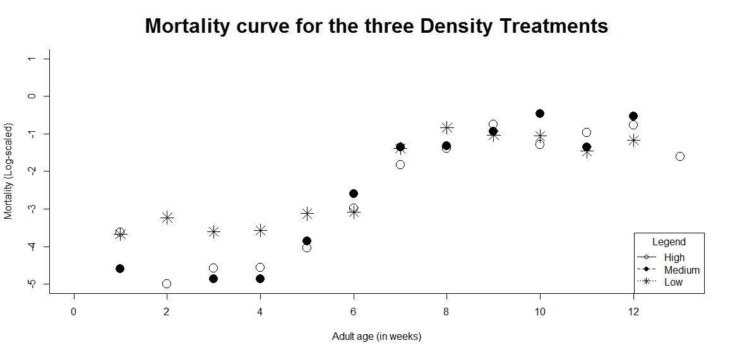

Now these models can be compared to different ageing models to see what fits best

**HIGH**

> flexsurvreg(survH ~ 1, dist="exp")

Call: flexsurvreg(formula = survH ~ 1, dist = "exp")

Estimates:

est L95% U95% se

rate 0.09016 0.07923 0.10260 0.00595

N = 303, Events: 230, Censored: 73

Total time at risk: 2551

**Log-likelihood = -783.4171, df = 1**

**AIC = 1568.834**

> flexsurvreg(survH ~ 1, dist="gompertz")

Call: flexsurvreg(formula = survH ~ 1, dist = "gompertz")

Estimates:

est L95% U95% se

shape 0.45863 0.40692 0.51034 0.02638

rate 0.00501 0.00325 0.00771 0.00110

N = 303, Events: 230, Censored: 73

Total time at risk: 2551

**Log-likelihood = -607.2486, df = 2**

**AIC = 1218.497**

**MEDIUM**

> flexsurvreg(survM ~ 1, dist="exp")

Call: flexsurvreg(formula = survM ~ 1, dist = "exp")

Estimates:

est L95% U95% se

rate 0.09738 0.08732 0.10860 0.00542

N = 394, Events: 323, Censored: 71

Total time at risk: 3317

**Log-likelihood = -1075.32, df = 1**

**AIC = 2152.64**

> flexsurvreg(survM ~ 1, dist="gompertz")

Call: flexsurvreg(formula = survM ~ 1, dist = "gompertz")

Estimates:

est L95% U95% se

shape 0.47014 0.42732 0.51296 0.02185

rate 0.00504 0.00351 0.00723 0.00093

N = 394, Events: 323, Censored: 71

Total time at risk: 3317

**Log-likelihood = -809.0766, df = 2**

**AIC = 1622.153**

**LOW**

> flexsurvreg(survL ~ 1, dist="exp")

Call: flexsurvreg(formula = survL ~ 1, dist = "exp")

Estimates:

est L95% U95% se

rate 0.10182 0.08533 0.12150 0.00918

N = 158, Events: 123, Censored: 35

Total time at risk: 1208

**Log-likelihood = -403.9981, df = 1**

**AIC = 809.9961**

> flexsurvreg(survL ~ 1, dist="gompertz")

Call: flexsurvreg(formula = survL ~ 1, dist = "gompertz")

Estimates:

est L95% U95% se

shape 0.37886 0.31342 0.44430 0.03339

rate 0.01194 0.00726 0.01964 0.00303

N = 158, Events: 123, Censored: 35

Total time at risk: 1208

**Log-likelihood = -336.4717, df = 2**

**AIC = 676.9435**

In every case the Gompertz model produces a higher log likelihood value and a lower AIC. Therefore the gompertz model of increasing mortality with age best fits the data and we can run the coxph model.

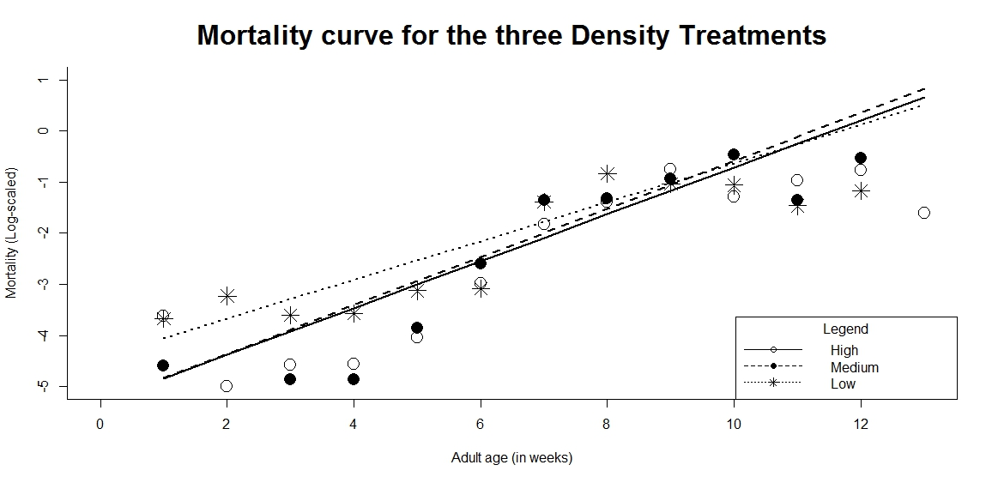Lines can be added to the plots as well